**Geometry Notes – 1.1 Points, Lines, and Planes**

**5 Minute Check**

1. What is the value of *x*2 + 3*yz* if *x* = 3, *y* = 6, and *z* = 4?

A. 27 B. 33 C. 72 D. 81

1. Solve 2(*x* – 7) = 5*x* + 4.

A. –6 B. $-\frac{10}{3}$ C. 2 D. 6

1. Which is a solution of 3*x* + 4*y* = 14?

A. (–3, 4) B. (–2, 5) C. (1, 3) D. (2, 3)

1. Factor 9*x*2 – 25*y*2.

A. (3*x* – 5*y*)2 B. (3*x* + 5*y*)2 C. (3*x* + 5*y*)(3*x* – 5*y*) D. (9*x* + 5*y*)(*x* – 5*y*)

1. Graph *y* = 3*x* + 2.
2. B. C. D.

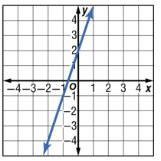 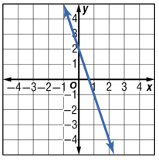 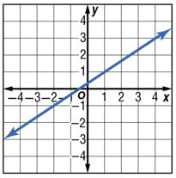 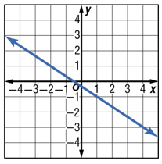

1. Which of the following equations is a quadratic equation?

A. 4*x* = 2 B. 5*x* + 2*y* = 13 C. 6*x*2 – 3*x* = 16 D. 5*x*3 – *x*2 + 2 = 0

**Content Standards**

G.CO.1 Know precise definitions of angle, circle, perpendicular line, parallel line, and line segment, based on the undefined notions of point, line, distance along a line, and distance around a circular arc.

**Mathematical Practices**

4 Model with mathematics.  
6 Attend to precision.

|  |  |  |
| --- | --- | --- |
| **Vocabulary – Undefined Terms (which are Intuitive Ideas) – Points, Line, & Plane** | | |
| **Term Description** | **How to Name It (Represent It)** | **Diagram (How to Draw It)** |
| **Point** – is a _________________.  It has neither ______ nor _______. | **Draw:** ____________  **Named By:** a ______________ letter | Fill this in! |
| **Line** – made up of _________ and  has no ____________ or _______.  There is exactly ______ line  through any _____ points. | **Draw:** a ___________ with  _________ on _________ ends  **Named By:** the ______________  representing _______ points on  the ______ or a _______________  script __________. | Fill this in! |
| **Plane** – a _______ surface made  up of ___________ that extends  infinitely in ______ directions.  There is exactly ______ plane  through any _________ points not  on the same line. | **Draw:** a ______________________  **Named By:** a _________ script  ___________ or by the  ___________ naming _______  points that are not all on the  _______ _______. | Fill this in! |

**Example 1 –** Name Lines and Planes

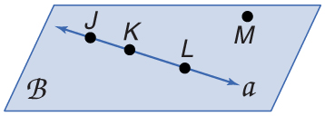

1. Use the figure to name a line containing point *K*.
2. Use the figure to name a plane containing point *L*.

**Example 1 –** Check Your Progress

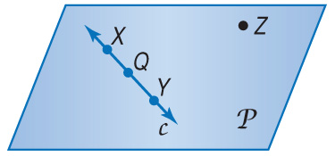

A. Use the figure to name a line containing the point *X*.

A. line *X* B. line *c* C. line *Z* D. 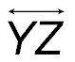

B. Use the figure to name a plane containing point *Z.*

A. plane XY B. plane c C. plane XQY D. plane P

**Real-World Example 2 –** Model Points, Lines, and Planes

1. Name the geometric shape modeled by a 10 × 12 patio.
2. Name the geometric shape modeled by a button on a table.

**Real-World Example 2 –** Check Your Progress

A. Name the geometric shape modeled by a colored dot on a map used to mark the location of a city.

A. point B. line segment C. Plane D. none of the above

B. Name the geometric shape modeled by the ceiling of your classroom.

A. point B. line segment C. Plane D. none of the above

|  |  |  |
| --- | --- | --- |
| **Vocabulary – Space, Collinear Points, Coplanar Points, & Intersection** | | |
| **Term Description** | **Explain in Your Own Words** | **Diagram** |
| **Space** – a __________________,   __________ dimensional set of all   points. Space can contain  ________ and __________. |  |  |
| **Collinear Points** – points that lie  on the __________ _______.  Noncollinear points ____ ______  lie on the ________ ________. | Fill this in! | Fill this in! |
| **Coplanar Points** – points that lie  in the ______ ________.  Noncoplanar points _____ ______  lie in the _______ ________. | Fill this in! | Fill this in! |
| **Intersection** – of two or more   geometric figures, is the set of  points they have ____ _________.  Two lines intersect at a ________.  Lines can intersect _________,  and planes can intersect ________  __________. | Fill this in! | Fill this in! |

**Example 3 –** Draw Geometric Figures

A. Draw and label a figure for the following situation. Plane *R* contains lines AB and DE, which intersect at point *P.* Add point *C* on plane *R* so that it is not collinear with $\overset{⃡}{AB}$ or $\overset{⃡}{DE}$.

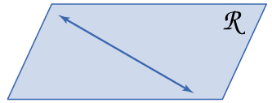

B. Draw and label a figure for the following situation. $\overset{⃡}{QR}$ on a coordinate plane contains Q(-2, 4) and R(4, -4). Add point T so that T is collinear with these points.

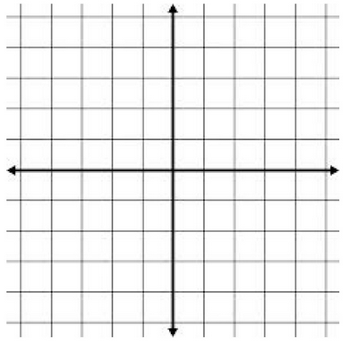

**Example 3 –** Check Your Progress

1. Choose the best diagram for the given relationship. Plane *D* contains line *a*, line *m*, and line *t*, with all three lines intersecting at point *Z.* Also, point *F* is on plane *D* and is not collinear with any of the three given lines.

A. B.

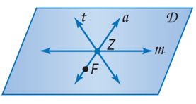 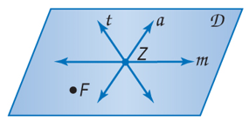

C. D.

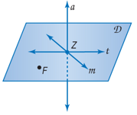 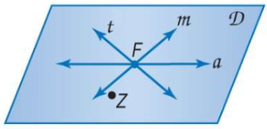

1. Draw and label a figure for each relationship. $\overset{⃡}{BA}$ on a cooridinate plane contains B(-3, -2) and   
   A(3, 2). Also, point *M* is on the plane and is collinear with these points.



**Example 4 –** Interpret Drawings

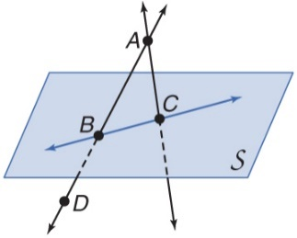

1. How many planes appear in this figure? B. Name three points that are collinear.

C. Are points *A*, *B*, *C*, and *D* coplanar? Explain. D. At what point do $\overset{⃡}{DB}$ and $\overset{⃡}{CA}$ intersect**.**

**Example 4 –** Check Your Progress

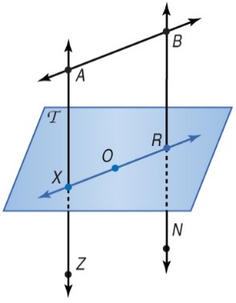

1. How many planes appear in this figure?

A. oneB. two C. three D. four

1. Name three points that are collinear.

A. *B*, *O*, and *X* B. *X*, *O*, and *N* C. *R*, *O*, and *B* D. *A*, *X*, and *Z*

1. Are points *X, O,* and *R* coplanar?

A. yes B. No C. cannot be determined

1. At what point do $\overset{⃡}{BN}$ and $\overset{⃡}{XO}$ intersect?

A. point *X* B. point *N* C. point *R* D. point *A*