www.learnalbert.ca
Click on English


In the Keyword search, type exploring laws of exponents and click search

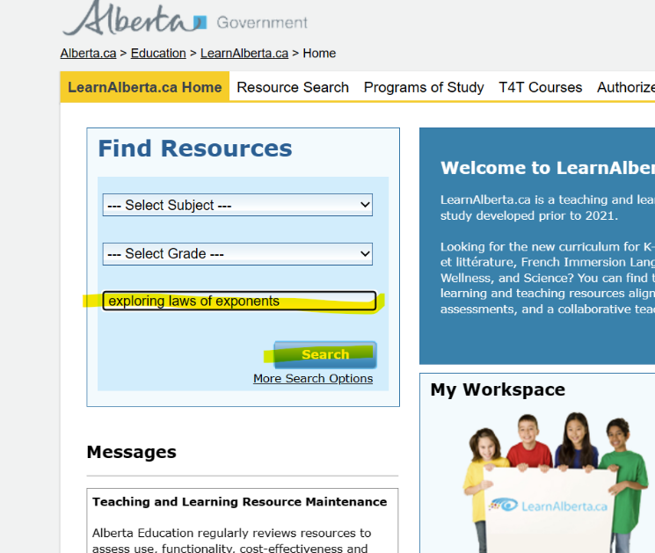

Click on Exploring Laws of Exponents

