Name_______________________________

Nickels Everywhere!

Nickel, nickel,
Thick and fat.
You’re worth five cents,
I know that!

Add the nickels. Remember to skip count by 5’s.

1. 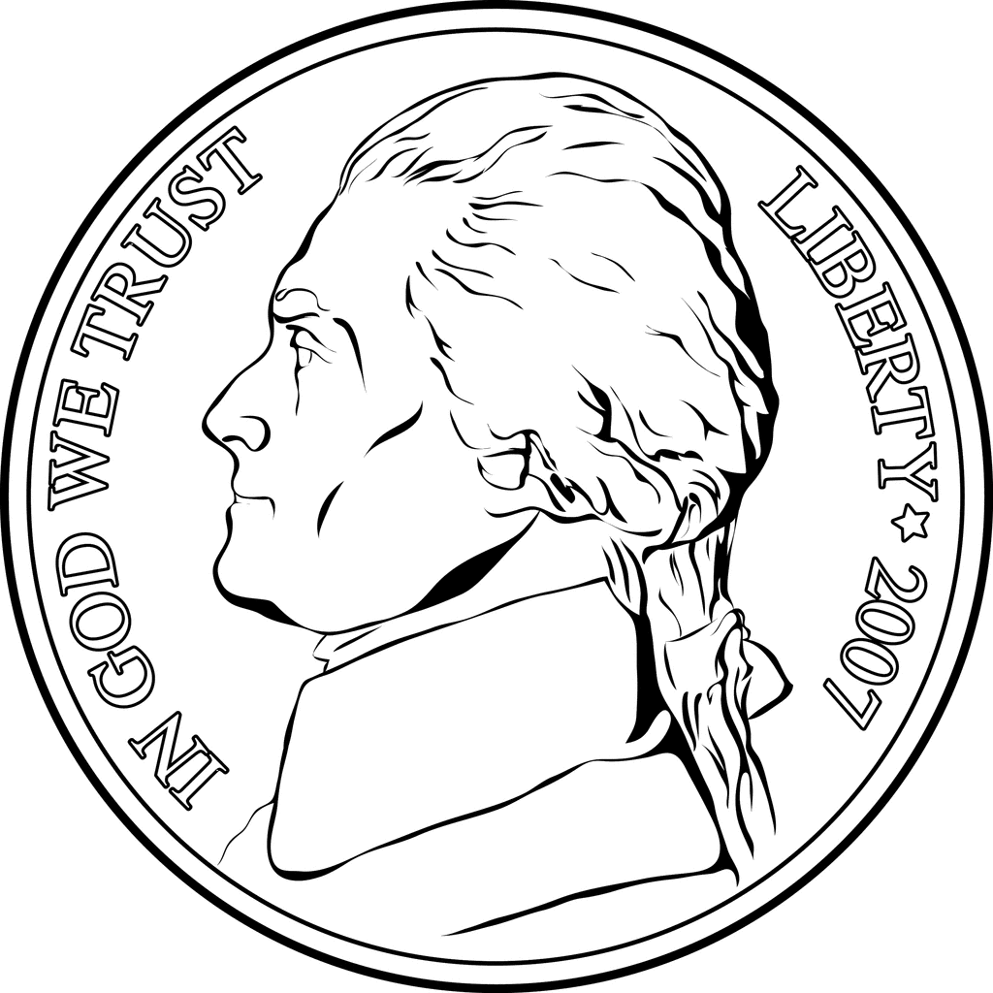 _____________

2. _____________

3. _____________

4. _______________
5.
______________

6.
______________

7.
______________

8. _______________

